**Project Design Phase-II**

**Technology Stack (Architecture & Stack)**

|  |  |
| --- | --- |
| Date | 01 Nov 2023 |
| Team ID | NM2023TMID04500 |
| Project Name | Blogging: Create a Blog using Wordpress |

**Technical Architecture:**

The Deliverable shall include the architectural diagram as below and the information as per the table1 & table 2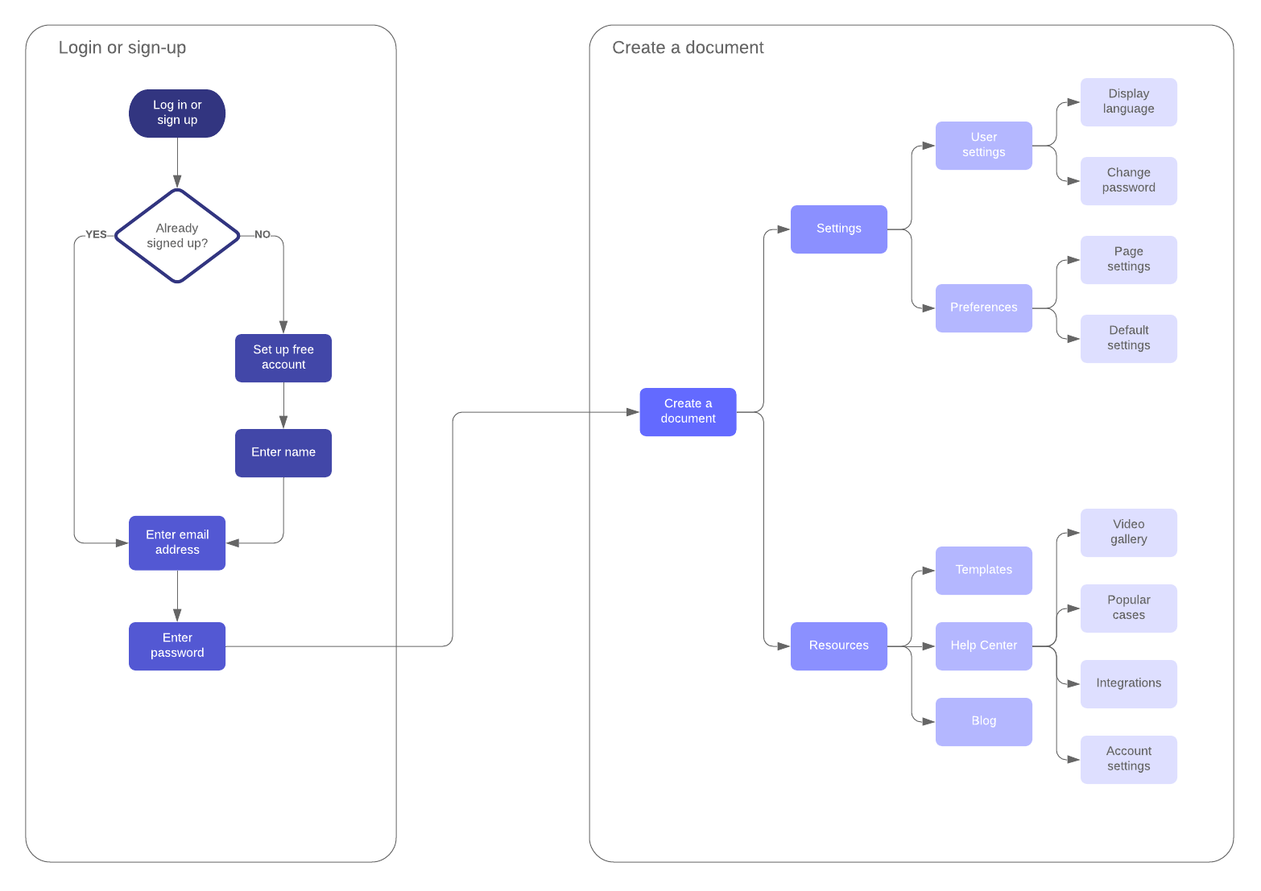

**Table-1: Components & Technologies:**

|  |  |  |  |
| --- | --- | --- | --- |
| **S. No** | **Component** | **Description** | **Technology** |
|  | Content Management System (CMS) | The CMS is the backbone of the "Mr. Panakkar" website, allowing for the easy creation, management, and publication of educational articles, videos, quizzes, and user-generated content. | WordPress - An industry-standard, open-source CMS known for its flexibility, user-friendliness, and extensive plugin ecosystem. |
|  | User profiles | User profiles provide a personalized space for each user, allowing them to showcase their trading experience, interact with the community, and access their personalized content. | Custom-built user profile system integrated with WordPress user management, including profile customization features and badges. |
|  | Community Forum | The community forum is the hub for users to engage in trading discussions, ask questions, and share experiences. It's an integral part of building a supportive community. | bbPress - A popular WordPress plugin for creating and managing discussion forums with user-friendly features. |
|  | Educational Content | Educational content includes articles, videos, and quizzes designed to educate users about trading concepts and strategies. | WordPress content types and custom fields, integrated with multimedia plugins for video content and quiz creation. |
|  | Branding Customization | Branding customization allows users to personalize their user profiles, theme appearance, and branding elements to create a unique experience. | Custom-built user branding customization features integrated with WordPress theme customization. |
|  | Data Analytics and Personalization | Data analytics and personalization are crucial for tailoring content recommendations and user experiences based on individual user behavior and engagement history. | Data analytics tools, potentially using Google Analytics or similar, and machine learning algorithms for personalized content recommendations. |
|  | Monetization and Advertising | Security measures are essential to protect user data, and compliance ensures adherence to legal and regulatory standards. | SSL encryption, security plugins, regular security patch updates, and privacy policy management for compliance. |
|  | Security and Compliance | Security measures are essential to protect user data, and compliance ensures adherence to legal and regulatory standards. | SSL encryption, security plugins, regular security patch updates, and privacy policy management for compliance. |

**Table-2: Application Characteristics:**

| **S. No** | **Characteristics** | **Description** | **Technology** |
| --- | --- | --- | --- |
|  | User-Centric Design | The application is designed with a strong focus on user experience, providing intuitive navigation, clear content structure, and a personalized interface that caters to the needs of novice and prospective traders. | User experience (UX) design principles and responsive web design techniques are applied to create an engaging and user-friendly interface. |
|  | Performance Efficiency | The application is optimized for performance, ensuring quick load times and responsiveness, even during high traffic periods.. | Performance optimization techniques, such as content caching, content delivery networks (CDNs), and scalable hosting infrastructure, are used to enhance application speed |
|  | Data Security | Data security is a top priority, with robust measures in place to protect user data, including personal information, discussions, and trading activity data.. | The application utilizes SSL encryption for data transmission, firewall and intrusion detection systems, secure user authentication, and regular security audits |
|  | Accessibility and Inclusivity | The application is designed to be accessible to users with disabilities, ensuring compliance with accessibility standards (e.g., WCAG) for inclusive user experiences. | Development practices that adhere to accessibility guidelines, including semantic HTML, alternative text for images, and keyboard navigation, are implemented. |
|  | Monetization Strategies | The application supports multiple monetization strategies, including premium content access and advertising sections, to sustain and enhance the project. | Integration of e-commerce plugins, ad management plugins, and affiliate marketing technologies are used to implement and manage these strategies |